Name: ________________________________ Date: ___________________________________

Class: _________________________________ Teacher: ___________________________________

# Math Mini Quiz 4

This Mini Quiz, we’re going to explore the math concepts that you’ve learned so far in this unit. This assignment should take you about **25 minutes**.

1) Which of the following are functions? Explain how you know for each function

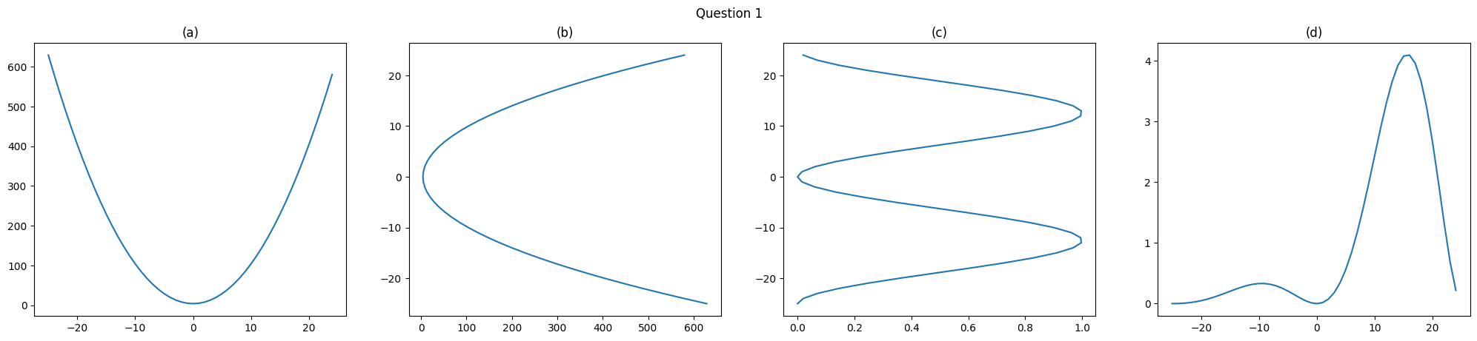

A train starts 120 miles away from your hometown. It travels at a constant speed (rate of change) of 30 miles per hour until it reaches your city*.

2) Write a function, *d(h)* for the distance the train is from your city as a function of hours *h*.

3) Graph the equation on the plot on the right. Pay attention to using an appropriate range and domain.

4) After how long does the train arrive in your city? **Circle** the time when the train arrives in your city on the graph.

A “normal” human body temperature is around 99° F. When you take your body temperature, it may be of interest to calculate how far away you are from this “normal” body temperature you are. The “how far away you are” can be expressed as an *error* function which is an absolute value function like:

*e(T) =* |*99 - T*|

3) Graph this function on the plot to the right for *90 < T < 109.*

4) Write this function as a piecewise function.

5) What is the minimum value of the error function? Where does it occur?

6) Assume doctors say a difference of more than 5° from the normal temperature is cause for concern. (a) Draw the horizontal line: *y = 5*. Circle the point(s) where this line intercepts with the function *e(T)*.

(b) What do these interception points tell us?

(c ) *e(T)* and *y = 5*, solve for the temperature at which these interceptions occur.